**SMART TAXI WEB APPLICATION–EFFICIENT RANKING ALGORITHM FOR VEHICLE MANAGEMENT SYSTEM**



**PROJECT REPORT**

**Submitted to**

**DEPARTMENT OF COMPUTER SCIENCE**

**GOBI ARTS & SCIENCE COLLEGE**

**(An Autonomous Co-educational Institution Affiliated to Bharathiar University,**

**Accredited With ‘A’ Grade by NAAC (4th Cycle) )**

**GOBICHETTIPALAYAM -638 453**

**By**

**S. HARIPRASATH**

**(22-06-121)**

**Guided By**

**Dr. R. PRABAHARI, M.C.A., M.Sc(CS)., M.Phil., Ph.D.,**

In partial fulfillment of the requirements for the award of the degree of **Master of Science (Computer Science),** in the faculty of Computer Science **in Gobi Arts & Science College (Autonomous), Gobichettipalayam** affiliated to Bharathiar University, Coimbatore.

**APRIL-2024**

**DECLARATION**

**DECLARATION**

I hereby declare that the project report entitled **“SMART TAXI WEB APPLICATION-EFFICIENT RANKING ALGORITHM FOR VEHICLE MANAGEMENT SYSTEM”** submitted to the **Principal, Gobi Arts & Science College (Autonomous), Gobichettipalayam,** in partial fulfillment of the requirement for the award of the degree of **Master of Science (Computer Science),** is a record of project work done by me during the period of study in this college under the guidance and supervision of **Dr. R. PRABAHARI, M.C.A., M.Sc(CS)., M.Phil., Ph.D., Associate Professor, Department of Computer Science**.

Signature :

Name : **S. HARIPRASATH**

Register No : **22-06-121**

Date :

**CERTIFICATE**

**CERTIFICATE**

This is to certify that the project report entitled **“SMART TAXI WEB APPLICATION-EFFICIENT RANKING ALGORITHM FOR VEHICLE MANAGEMENT SYSTEM”** is a bona fide work done by **S. HARIPRASATH (22-06-121)** under my supervision and guidance.

Signature of the Guide :

Name : **R. PRABAHARI**

Designation : Associate Professor

Department : Computer Science

Date :

**Counter-Signed**

**Head of Department Principal**

**Viva-Voce held on : ________________**

**Internal Examiner External Examiner**

**ACKNOWLEDGEMENT**

**ACKNOWLEDGEMENT**

I would like to express my deep sense of gratitude and obligation to college council for providing necessary facilities given me the opportunity to do the entire college studies in Gobi Arts & Science College (Autonomous), Gobichettipalayam.

I wish to record my deep sense of gratitude to our beloved Principal **Prof. Dr. V. THIAGARASU, M.Sc., PGDCA., M.Phil., B.Ed., Ph.D.,** Gobi Arts & Science College (Autonomous), Gobichettipalayam for inspiration which made me to complete this project successfully.

I would like to acknowledge my gratitude to our beloved Head of the Department **Dr. K.A. SENTHILDEVI, M.C.A., M.Phil., Ph.D.,** Associate Professor, Department of Computer Science, Gobi Arts & Science College (Autonomous), Gobichettipalayam cheerful encouragement and supporting me as a lot who have given me overwhelming support this project has been completed with in the stipulated time.

I express my sincere thanks and gratitude to my project guide **Dr. R. PRABAHARI, M.C.A., M.Sc(CS)., M.Phil., Ph.D.,** Associate Professor, Department of Computer Science, Gobi Arts & Science College (Autonomous), Gobichettipalayam with her valuable guidance and constructive suggestion, kind co-operation and encouragement throughout the project.

I am very much indebted to all faculty members of Computer Science and the programmers for their effort to complete this project successfully.

Finally I express my thanks to my family and my friends for their moral support to this project work.

**S. HARIPRASATH**

i

**SYNOPSIS**

**SYNOPSIS**

This project entitled **“SMART TAXI WEB APPLICATION-EFFICIENT RANKING ALGORITHM FOR VEHICLE MANAGEMENT SYSTEM”** is developed for the purpose for to prioritize vehicles based on a comprehensive set of factors. The algorithm considers vehicle health status, availability, usage history, fuel efficiency, capacity matching, predictive maintenance needs, cost optimization, real-time demand, regulatory compliance, environmental impact, and user preferences.

Vehicles are sorted based on their weighted scores in descending order. This will give the ranked list of vehicles.

The project has been developed by using HTML, BOOTSTRAP as front end and PHP as back end.

ii

**CONTENTS**

**CONTENTS**

ACKNOWLEDGEMENT i

SYNOPSIS ii

**CHAPTER TITLE**  **PAGE NO**

**1. INTRODUCTION 1**

1.1 ORGANIZATION PROFILE 1

1.2 ABOUT THE PROJECT 2

1.3 HARDWARE SPECIFICATION 3

1.4 SOFTWARE SPECIFICATION 3

**2. SYSTEM ANALYSIS 10**

2.1 PROBLEM DEFINITION 10

2.2 SYSTEM STUDY 10

2.2.1 EXISTING SYSTEM 11

2.2.2 PROPOSED SYSTEM 12

**3. SYSTEM DESIGN 13**

3.1 DATA FLOW DIAGRAM 13

3.2 ER DIAGRAM 14

3.3 FILE SPECIFICATION 15

3.4 MODULE SPECIFICATION 18

**4. TESTING AND IMPLEMENTATION** 19

**5**. **CONCLUSION AND SUGGESTIONS**  22 **BIBLIOGRAPHY**

**APPENDICES PAGE NO**

**APPENDIX – A (SCREEN FORMATS) 24**

A1. CAB ADD FORM 24

A2. CAB EDIT FORM 25

A3. CAB MODEL ADD FORM 26

A4. CAB MODEL EDIT FORM 27

A5. VEHICLE ADD FORM 28

A6. VEHICLE EDIT FORM 29

**APPENDIX – B (REPORTS) 30**

B1. CAB VIEW REPORT 30

B2. CAB MODEL VIEW REPORT 31

B3. VEHICLE VIEW REPORT 32

**INTRODUCTION**

**1.INTRODUCTION**

**1.1 ORGANIZATION PROFILE**

SBS Technologies is a software company based in Erode, Tamil Nadu, India. It was founded in 2011 by **Mrs.Shanthi Subramanian & Mr. Babu Subramanian.**

The company provides a wide range of software development services, including website development, mobile application development, and software testing. SBS Technologies also offers training courses on various software development technologies. The company has a team of experienced and qualifiedsoftware developers who are experts in a variety of programming languages and technologies.

SBS Technologies has a proven track record of delivering high-quality software solutions to its clients. The company is committed to providing its clients with the best possible service and support. SBS Technologies is a leading provider of software development services in Erode. The company had a strong reputation for quality, reliability, and customer service. SBS Technologies is a trusted partner for businesses of all sizes. Here are some of the services offered by SBS Technologies.

If you are looking for a reliable and experienced software development company, then SBS Technologies is the right choice for you. The company has a team of experts who can help you with all of your software development needs. SBS Technologies is committed to providing its clients with the best possible service and support.

**MISSION, VALUES & OBJECTIVES**

At SBS Technologies, their vision extends beyond the point of development to create a better experience for new technology. Their products and service support their mission by offering a diverse range of tools and resources that are easy to use, trusted and reliable.

Their mission is based on three main principles.

* Client satisfaction.
* Deliver their service effectively and efficiently.
* Offering very competitive prices. As simple as these principles, they stand firm and persistent at administering into their day to day operations.

\

**1.2 ABOUT THE PROJECT**

Ranking algorithm can be used for vehicle management, depending on the specific requirements and criteria for ranking. It is used to rank items in a dataset according to some criterion. Ranking by similarity, distance, preferences, and probability are the most common types of ranking algorithms. The effective management of vehicles within a fleet is crucial for optimizing resource utilization, minimizing operational costs, and enhancing overall efficiency in a vehicle management system (VMS).

The efficient ranking algorithm designed to prioritize vehicles based on a comprehensive set of factors. The algorithm considers vehicle health status, availability, usage history, geographical proximity, fuel efficiency, capacity matching, driver ratings, predictive maintenance needs, cost optimization, emergency handing, real-time demand, regulatory compliance, environmental impact, and user preferences. By integrating these diverse parameters, the algorithm aims to dynamically assign priority rankings to vehicles, ensuring optimal fleet performance. The scalability of the algorithm enables its application in various fleet sizes and operational complexities. Vehicles are sorted based on their weighted scores in descending order.

This will give you the ranked list of vehicles. Continuous monitoring, data analysis, and improvements based on user feedback and changing operational conditions contributes to the algorithm’s adaptability and effectiveness in addressing many challenges of vehicle management within a dynamic and evolving transportation system.

**1.3 HARDWARE SPECIFICATION**

Processor : Intel Pentium III or higher

RAM : 4 GB

Storage space : 50 GB

Monitor : 18 LED Monitor

Mouse : USB Optical Mouse

Keyboard : Multimedia Keys

**1.4 SOFTWARE SPECIFICATION**

Web Browser : Google chrome

Operating System : Windows 10

Front-End : HTML, BOOTSTRAP

Back-End : PHP, MySQL

**FEATURES OF PROGRAMMING TOOLS**

**OPERATING SYSTEM-WINDOWS 10**

Microsoft’s most recent and sophisticated operating system. Since its launch in 2015, Windows 10 has surpassed all other desktop operating systems in terms of usage.

The elegant and user-friendly interface of Windows 10 is well known for making it simple for both casual and power users to navigate and customize their devices.

The adaptability of Windows 10 is one of its main advantages. Whether you’re a power user who has to run numerous applications and programs at once or a casual user who just uses your tablet for web browsing and email, Windows 10 has plenty to offer.

Windows 10 is made to help you work more successfully and efficiently thanks to its robust multitasking capabilities and configurable interface.

The dependability of windows 10 is another asset. Microsoft routinely issues patches and updates to fix security flaws and enhance performance, making sure that your device is always up-to-date and secure.

Microsoft also offers substantial online documentation, discussion boards, and direct customer assistance for Windows 10 users.

Windows 10 incorporates multi-factor authentication technology based upon standards developed by the FIDO Alliance. The operating system includes improved support for biometric authentication through the Windows Hello platform. Devices with supported cameras (requiring infrared illumination, such as Intel RealSense) allow users to log in with iris or face recognition, similarly to Kinect. Devices with supported readers allow users to log in through fingerprint recognition. Support was also added for palm-vein scanning through a partnership with Fujitsu in February 2018. Credentials are stored locally and protected using asymmetric encryption.

**FEATURES OF WINDOWS-10**

* Cortana
* Start menu
* Improved multitasking
* Xbox integration

**Command line**

The console windows based on Windows Console (for any console app, not just PowerShell and Windows Command Prompt) can now be resized without any restrictions, can be made to cover the full screen by pressing All Enter, and can use Standard keyboard shortcuts, such as those for cut, copy, and paste. Other features such as word wrap and transparency were also added. These functions can be disabled to revert to the legacy console if needed.

**Storage requirements**

To reduce the storage footprint of the operating system, Windows 10 automatically compressed system files. The system can reduce the storage footprint of Windows by approximately 1.5 GB for 32-bit systems and 2.6 GB for 64-bit systems. The level of compression used is dependent on a performance assessment performed during installations or by OEMs, which tests how much compression can be used without harming operating system performance.

**Online service and functionality**

Windows 10 introduces Microsoft Edge, a new default web browser. It initially featured a new standards-compliant rendering engine derived from Trident, and also includes annotation tools and integration with other Microsoft platforms present within Windows 10. Internet Explorer 11 is maintained on Windows 10 for compatibility purposes, but is deprecated in favour of Edge and will no longer be actively developed.

**HTML**

HTML, or Hyper Text Markup Languages, is the standard language for creating web pages. It uses tags to structure content, such as headings(‘<h1>’), paragraphs (‘<p>’), and links (‘<a>’). HTML documents have a basic structure with a head section for meta-information and a body section for content. Tags can have attributes, like the “href” attribute in links.

HTML is fundamental for web development, providing a standardized way to present information on the internet.

**BOOTSTRAP**

Bootstrap is a popular and free front-end framework that helps developers create modern and responsive websites and web applications more easily. It provides a set of pre-designed components (like buttons, forms navigation bars, ect.) and a responsive grid system that makes it simpler to build consistent and visually appealing user interfaces. Bootstrap is open-source, widely used, and helps save time and effort in web development by offering a standardized and customizable set of tools.

In addition to the simplicity and efficiency it brings to web development, Bootstrap can be seen as a toolbox or a collection of ready-made building blocks for designing websites.

Bootstrap not only simplifies the technical aspects of web development but also promotes consistency, flexibility, accessibility, and collaboration within the web development community. It’s a versatile tool that empowers developers to create professional and responsive web interfaces efficiently.

* Rapid Development: Bootstrap allows for quick development of websites and web applications by providing a collection of pre-built components.
* Responsive Design: It is designed with a mobile-first approach, ensuring that websites are responsive and adapt well to various screen sizes.
* Consistent Grid System: Bootstrap’s 12-column grid system provides a structured layout, making it easier to create a consistent and organized design.
* Cross-Browser Compatibility: Bootstrap ensures that your website looks and functions consistently across different web browsers.
* Time Efficiency: Developers can save time by using Bootstrap’s pre-designed components and styles, reducing the need for extensive custom coding.
* Customization: While offering default styles, Bootstrap is highly customizable. developers can easily modify the framework to meet the specific design requirements of their projects.
* Comprehensive Documentation: Bootstrap comes with through documentation, including examples and explanations, making it easy for developers to understand and use its features.
* Community Support: As an open-source framework, Bootstrap has a large and active community of developers. This community provides resources, forums, and support for troubleshooting and learning.
* JavaScript Components: Bootstrap includes optional JavaScript components like modals, tooltips, and carousels, which can be easily integrated into projects for enhanced functionality.
* Consistent Styling: Bootstrap follows a consistent design language, allowing developers to create a cohesive and professional-looking interface for their websites.
* Accessibility: Bootstrap is designed with accessibility in mind, adhering to best practices to ensure that websites are usable by people with disabilities.

**Cascading Style Sheets**

Cascading Style Sheets, commonly known as CSS, is a styling language used in web development. In simple terms, CSS is used to control the presentation and layout of HTML documents. It defines how HTML elements should be displayed on a webpage, including aspects like colors, fonts, spacing, and positioning. CSS allows developers to separate the structure (HTML) and design (CSS) of a website, making it easier to create visually appealing and consistent web pages.

Certainly! In simpler terms, Cascading Style Sheets (CSS) is like the makeup for a website. It’s the language used to make web pages look good by controlling the colors, fonts, spacing, and overall layout. Just as makeup enhances a person’s appearance, CSS enhances the visual appeal of a website by styling the elements on the page.

**PHP**

PHP stands for "Hypertext Preprocessor." In simple terms, PHP is a programming language commonly used for web development. It is embedded within HTML code to create dynamic and interactive web pages. PHP is server-side, meaning that it is executed on the web server, and the results are sent to the user's web browser. It is particularly well-suited for tasks such as processing form data, interacting with databases, and generating dynamic content on websites.

* Free to use.
* Extensive library.
* Adaptable with multiple platforms and technologies.
* Community support.
* Easier maintenance.
* Large choice of available specialists.
* Improved loading speed.
* Wide selection of databases.

**FEATURES OF PHP**

**Performance:**

PHP script is executed much faster than those scripts which are written in other languages such as JSP and ASP.PHP uses its own memory, so the server workload and loading time is automatically reduced, which results in faster processing speed and better performance.

**Open Source:**

PHP source code and software are freely available on the web. You can develop all the versions of PHP{ according to your requirement without paying any cost. All its components are free to download and use.

**Familiarity with syntax:**

PHP has easily understandable syntax. Programmers are comfortable coding with it.

**Embedded:**

PHP code can be easily embedded within HTML tags and script.

**Platform Independent:**

PHP is available for WINDOWS, MAC, LINUX & UNIX operating systems. A PHP application developed in one OS can be easily executed in other OS also.

**Database Support:**

PHP supports all the leading databases such as MySQL, SQLite, ODBC, etc.

**Error Reporting :**

PHP has predefined error reporting constants to generate an error notice or warning at runtime. E.g., E_ERROR, E_WARNING, E_STRICT, E_PARSE.

**Loosely Typed Language:**

PHP allows us to use a variable without declaring its datatype. It will be taken automatically at the time of execution based on the type of data it contains on its value.

**Web servers Support:**

PHP is compatible with almost all local servers used today like Apache, Netscape, Microsoft IIS, etc.

**Security:**

PHP is a secure language to develop the website. It consists of multiple layers of security to prevent threads and malicious attacks.

**Control:**

Different programming languages require long script or code, whereas PHP can do the same work in a few lines of code. It has maximum control over the websites like you can make changes easily whenever you want.

**A Helpful PHP Community:**

It has a large community of developers who regularly updates documentation, tutorials, online help, and FAQs. Learning PHP from the communities is one of the significant benefits.

**SYSTEM ANALYSIS**

**2.SYSTEM ANALYSIS**

**2.1 PROBLEM DEFINITION**

Lack of information to access vehicle ranking information based on price, mileage, history and condition. The algorithm needs to balance these factors to archive optimal fleet management. The ranking algorithm should adapt dynamically to real-time changes in demand, vehicle health, and other operational parameters. Designing the algorithm to handle emergency situation is vital. Ensuring that priority is given to vehicles capable of addressing urgent needs without compromising regular operations is a key aspect. Adhering to local regulatory requirements, emissions standards, and legal constrains while ranking vehicles adds an additional layer of complexity. Leads to huge vehicle maintenance costs. Balancing the need for cost optimization with other factors is a challenge. The algorithm should make informed decisions that align with the financial goals.

**2.2 SYSTEM STUDY**

A system study for an efficient ranking algorithm for a vehicle management system is a vehicles efficiency should be defined by its score, produced by an efficient ranking algorithm. To determine the factors that will be used to rank the vehicles. Assign weights to each criteria. Normalize the data to ensure in similar scale and calculate weighted score. Then ranked vehicle scores are sorted in descending order. This will give the ranked list of vehicles.

**2.2.1 EXISTING SYSTEM**

Existing system for an vehicle management system, vehicle details such as licence number, car model, manufacture year, owner information will be stored in the database. Vehicle inventory for each type of vehicle is maintained. It will be insured. Vehicle movements will be tracked and monitored. Vehicle are well-maintained and employ with pre-emotive, regular maintenance programmes. Updated individual vehicle files will be maintained. Vehicles and its usage are ensured to conform with safety regulations. Vehicle management system also done by fleet management software providers, telematics solutions, and transportation management system. This includes information on fuel efficiency, engine health, and other performance metrics. Some system employ predictive maintenance algorithms that analyse historical data and vehicle usage patterns to anticipate maintenance needs and to avoid unexpected breakdowns. Some systems incorporate cost analytics to optimize vehicle assignments based on operating costs, fuel efficiency, and other financial considerations.

**DRAWBACKS OF THE EXISTING SYSTEM**

* Vehicle table stores the many parameters.
* Limited user preference.
* Scalability issue.

**2.2.2 PROPOSED SYSTEM**

The proposed system of the vehicle management system, an efficient ranking algorithm is applied to vehicle management systems to solve the problem by collecting sample vehicle data such as name, price, age, mileage and condition of the vehicle. Weights will be defined for that criterion. By this algorithm weight scores Will be calculated for each vehicle. Then vehicles will be sorted based on their scores. Vehicle with higher health scores, well-maintained vehicles will be used more frequently. Vehicles that have been underutilized will be ensured a balanced distribution of workload among the fleet. Vehicles that are closer to the pickup points or destinations will be prioritized to minimize travel time. Data on fuel consumption and efficiency for each vehicle will be integrated. Vehicles with better fuel efficiency will be preferred to reduce operational costs. Capacity and size of vehicles will be considered in relation to the number of passengers or cargo to be transported to optimize the resource usage. Compliance with local regulations, emissions standards, and other legal requirements will be considered.

**BENEFITS OF PROPOSED SYSTEM**

* Efficient ranking algorithm uses for vehicle ranking system.
* Predict which vehicle gives the highest price, mileage, age, condition.
* Enhanced user experience.
* Improved operational efficiency.
* Optimized vehicle allocation.

**SYSTEM DESIGN**

**3.SYSTEM DESIGN**

**3.1 DATA FLOW DIAGRAM**

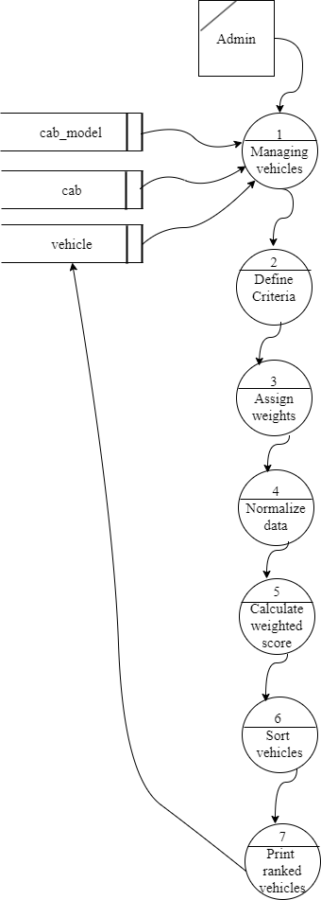

**3.2 ER DIAGRAM**

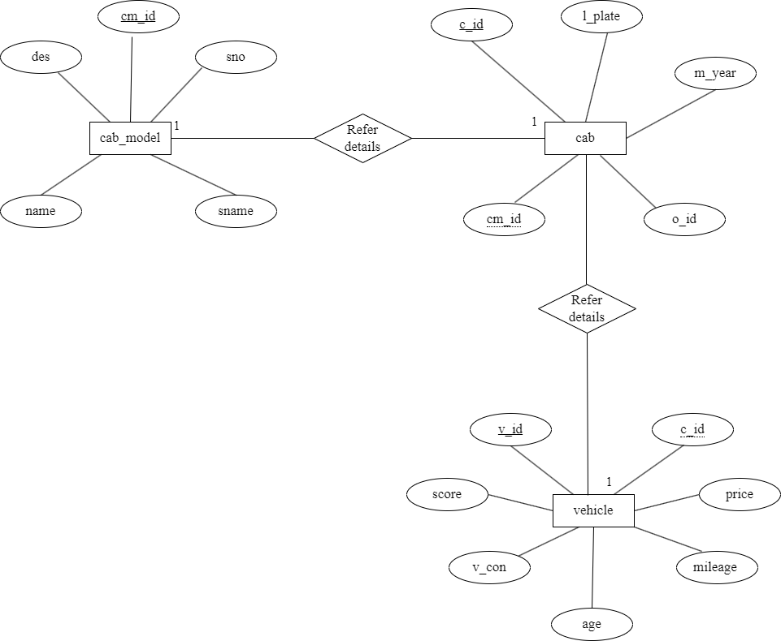

**3.3 FILE SPECIFICATION**

**Table Name** **:** CAB_MODEL

**Purpose :** It is used to store cab model information.

|  |  |  |  |  |
| --- | --- | --- | --- | --- |
| **FIELDNAME** | **DATATYPE** | **SIZE** | **CONSTRAINT** | **DESCRIPTION** |
| cm_id | INT | 11 | Primary Key | Car Model Id |
| sno | VARCHAR | 11 | Not Null | Serial Number |
| name | VARCHAR | 20 | Not Null | Name |
| sname | VARCHAR | 10 | Not Null | Short name |
| des | VARCHAR | 20 | Not Null | Description |
| status | TINY INT | 1 | Not Null | The status of the cab model  Can be active, inactive |

**Table Name :** CAB

**Purpose :** It is used to store cab information.

|  |  |  |  |  |
| --- | --- | --- | --- | --- |
| **FIELDNAME** | **DATATYPE** | **SIZE** | **CONSTRAINT** | **DESCRIPTION** |
| c_id | VARCHAR | 11 | Primary Key | Cab Id |
| l_palte | VARCHAR | 32 | Not Null | Licence Plate |
| cm_id | ITN | 11 | Foreign Key | Car Model Id |
| m_year | INT | 11 | Not Null | Manufacture Year |
| o_id | VARCHAR | 20 | Not Null | Owner Id |
| status | TINY INT | 1 | Not Null | The status of the cab can be active, inactive |

**Table Name :** VEHICLE

**Purpose :** It is used to store vehicle details

|  |  |  |  |  |
| --- | --- | --- | --- | --- |
| **FIELDNAME** | **DATATYPE** | **SIZE** | **CONSTRAINT** | **DESCRIPTION** |
| v_id | VARCHAR | 20 | Primary Key | Vehicle Id |
| c_id | VARCHAR | 11 | Foreign Key | Cab Id |
| price | DOUBLE | (11,2) | Not Null | Price |
| mileage | VARCHAR | 20 | Not Null | Mileage |
| age | VARCHAR | 10 | Not Null | Age(years) |
| v_con | TINY INT | 1 | Not Null | Vehicle Condition |
| score | VARCHAR | 20 | Not Null | Score |
| status | TINY INT | 1 | Not Null | The status of the vehicle can be active, inactive |

**3.4 MODULE SPECIFICATION**

**VEHICLE MANAGEMENT MODULE**

* CAB MODEL MODULE
* CAB MODULE
* VEHICLE MODULE

**CAB MODEL MODULE**

The Cab Model table is used to store the cab model details. This table associated with cab table.

**CAB MODULE**

The Cab table is used to store and manage detailed information about cab. This table associated with vehicle table.

**VEHICLE MODULE**

The vehicle table is used to store and manage detailed information about each vehicle. The vehicle efficiency should be defined by its scores. This table associated with cab table.

**IMPLEMENTING EFFICIENT RANKING ALGORITHM**

**Define the criteria for ranking**

Determine the factors that will be used to rank vehicles, such as price, mileage, age, condition.

**Assign weights to the criteria**

Assign weights to each criteria based on their importance in the ranking process. For example, if price is more important than mileage, assign a higher weight to price.

**Normalize the data**

Normalize the data for each criteria to ensure that they are on a similar scale. This can be done by dividing each value by the maximum value for that criteria.

**Calculate the weighted score**

Multiply each normalized value by its corresponding weight and sum them up to get the weighted score for each vehicle.

**Sort the vehicles**

Sort the vehicles based on their weighted score in descending order. This will give you the ranked list of vehicles.

**TESTING AND IMPLEMENTATION**

**4. TESTING AND IMPLEMENTATION**

**TESTING**

In the phase the software developed testing is exercising the software to uncover errors and ensure the system meet defined requirements. Testing may be done at 4 levels.

* Unit testing
* Integration testing
* Functional testing
* Performance testing
* Compatibility testing
* Scalability testing
* Regression testing
* User Acceptance testing

**UNIT TESTING**

Unit testing is the process where you test the individual component of system such as efficient ranking algorithm, functions, criteria, cab and cab model modules.

**INTEGRATION TESTING**

Test the interaction between cab and cab model modules. Ensure that the data is passed correctly between cab and cab model of the system.

**FUNCTIONAL TESTING**

Verify that the smart taxi web application functions according to the specified requirements. Test the core functionalities of the Smart Taxi Web Application, such as, producing efficient vehicle ranking defined by its score details.

**PERFORMANCE TESTING**

Evaluate the systems performance under various conditions, such as each vehicle efficiency and score details. Measure response times and resource usage to ensure the smart taxi application meets performance expectations.

**COMPATIBILITY TESTING**

Test the efficient ranking algorithm for vehicle management system on different browsers, devices, and operating systems to ensure compatibility.

**SCALABILITY TESTING**

Access the system ability to handle a growing number of ranking score details and ensure that the smart taxi web application scales effectively with increased demand.

**REGRESSION TESTING**

Regression testing is performed to find out that the new updates or changes do not negatively impact existing functionalities. Re-run previous tests to verify that the smart taxi web application remains stable.

**USER ACCEPTANCE TESTING**

User acceptance testing (UAT), or application testing, is the final stage of any software development. Involve actual users to validate that the smart taxi web application of efficient ranking algorithm meets the expectations. Gather vehicles feedback to make necessary improvements.

**IMPLEMENTATION**

The designed system must be implemented to fulfill development. There are many software implementation methods. In this system direct change over from existing system to computer is carried out. After system design is over, the user was consulted with a demonstration. This was done to find if any logical error occur in the system. Since the complete system has been developed according to user requirements, the demonstration is necessary.

Implementation is the stage of the project when the theoretical design is turned into a working system. It can be considered to be the most critical stage in achieving a successful new system and in giving the user confidence that the new system will work and be effective.

This system to implement an efficient ranking algorithm is applied to vehicle management system. The vehicle efficiency should be defined by its score details.

**CONCLUSION AND SUGGESTIONS**

**5.CONCLUSION AND SUGGESTIONS**

**CONCLUSION**

This application can now identify each vehicle rank uniquely. The each vehicles performance to be calculated with help of their scores. The efficient ranking algorithm should be used for calculate the each vehicles score and produced and ranking process. The scalability of the efficient ranking algorithm enables its application in various fleet sizes and operational complexities. Vehicles are sorted based on their weighted scores in descending order.

Vehicles with better fuel efficiency will be preferred to reduce operational costs. Capacity and size of vehicles will be considered in relation to the number of passengers or cargo to be transported to optimize the resource usage. Compliance with local regulations, emissions standards, and other legal requirements will be considered.

**SUGGESTIONS**

* Keep a record of drivers, their licenses, and training certifications to ensure compliance with regulations and safety standards.
* A separate rank should be given to drivers with special performance.
* Ensure compatibility with other systems like accounting software for streamlined financial tracking.
* Ensure the system stays up-to-date with technological advancements and industry best practices through regular updates and maintenance.

**BIBLIOGRAPHY**

**BIBLIOGRAPHY**

**I.BOOK REFERENCES**

1. Jacob Lett, “ Bootstrap Reference Guide ”, Bootstrap Creative Illustrated edition , 2018.
2. [James R. Groff](https://www.google.co.in/search?tbo=p&tbm=bks&q=inauthor:%22James+R.+Groff%22), “ SQL: The Complete Reference 3rd Edition ”, McGraw Hill Professional, 2008.
3. Steve Holzner, “ PHP: The Complete Reference ”, McGraw Hill Education, 2017.
4. Thomas A. Powell, “ HTML & CSS: The Complete Reference 5th Edition”, World journal East in India, 2011.
5. Thomas H. Cormen, “ Introduction to Algorithms ”, MIT Press Publishers, 2009.

**II.URL REFERENCES:**

1. en.wikipedia.org/wiki/PHP
2. https://careerride.com/PHP-types-errors.aspx
3. <https://getbootstrap.com/>
4. https://www.w3schools.com/php/php_namespaces.asp
5. In.pho.net
6. [www.stackoverflow.com](http://www.stackoverflow.com)

**APPENDICES**

**APPENDIX – A (SCREEN FORMATS)**

**A1. CAB ADD FORM**

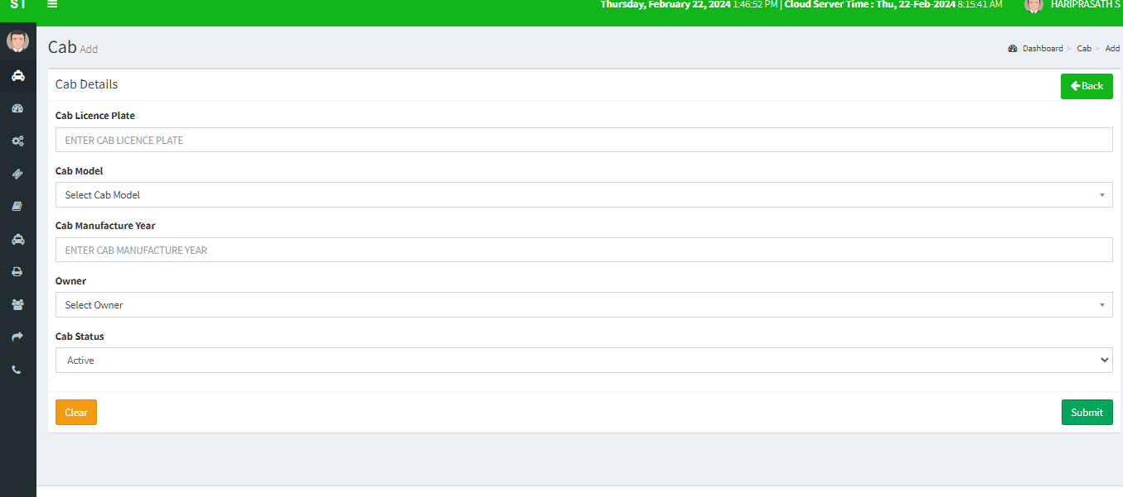

**A2. CAB EDIT FORM**

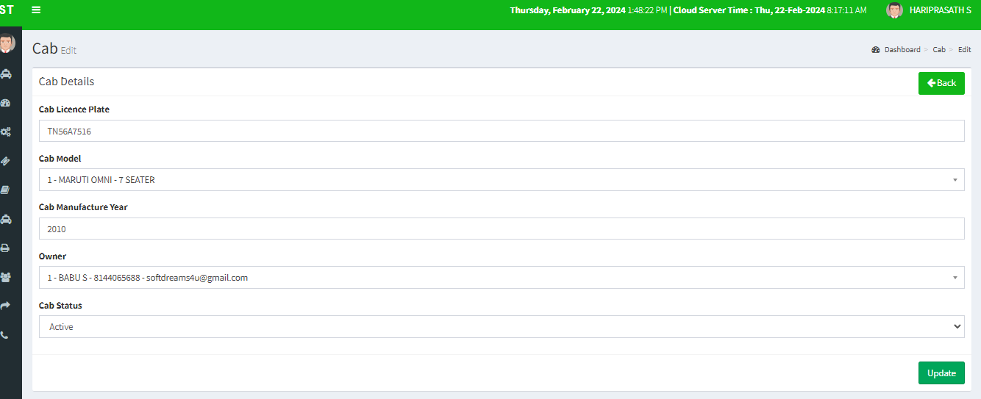

**A3. CAB MODEL ADD FORM**

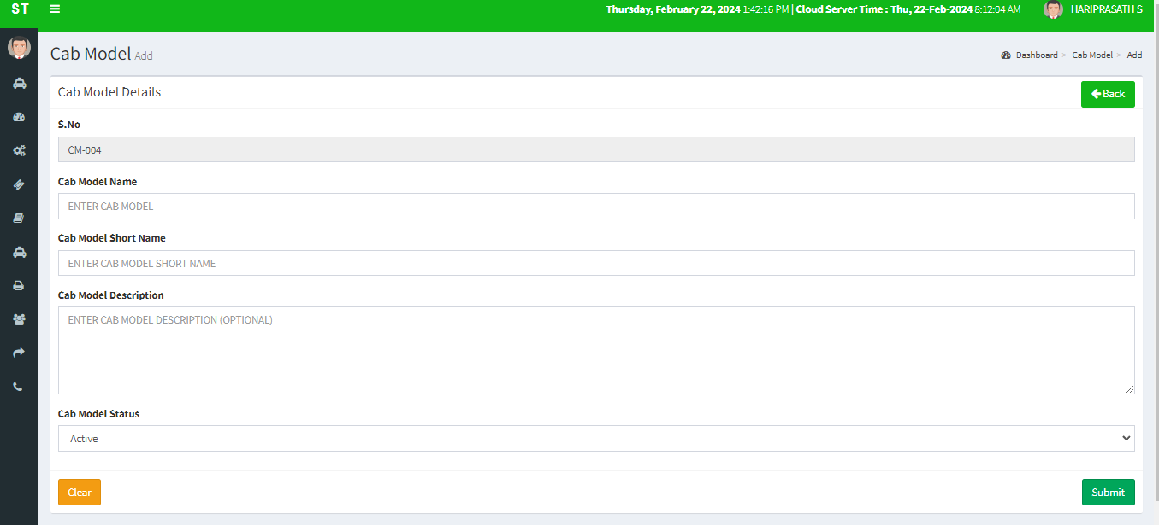

**A4. CAB MODEL EDIT FORM**

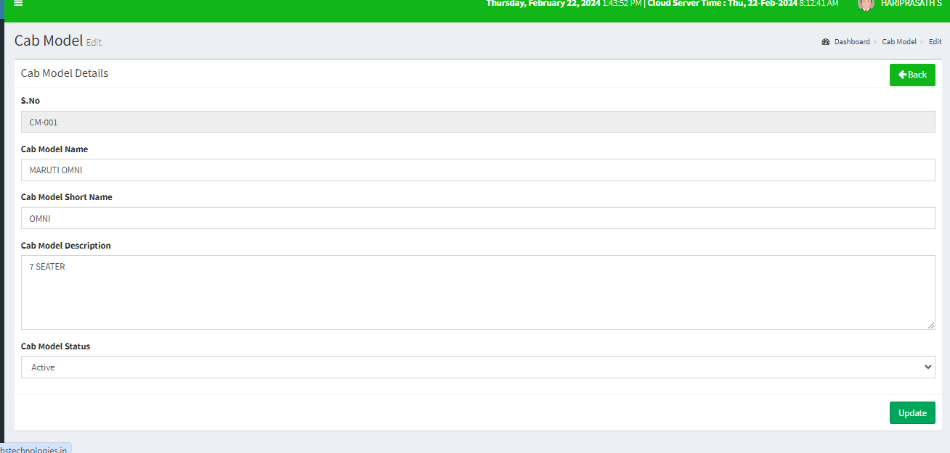

**A5. VEHICLE ADD FORM**

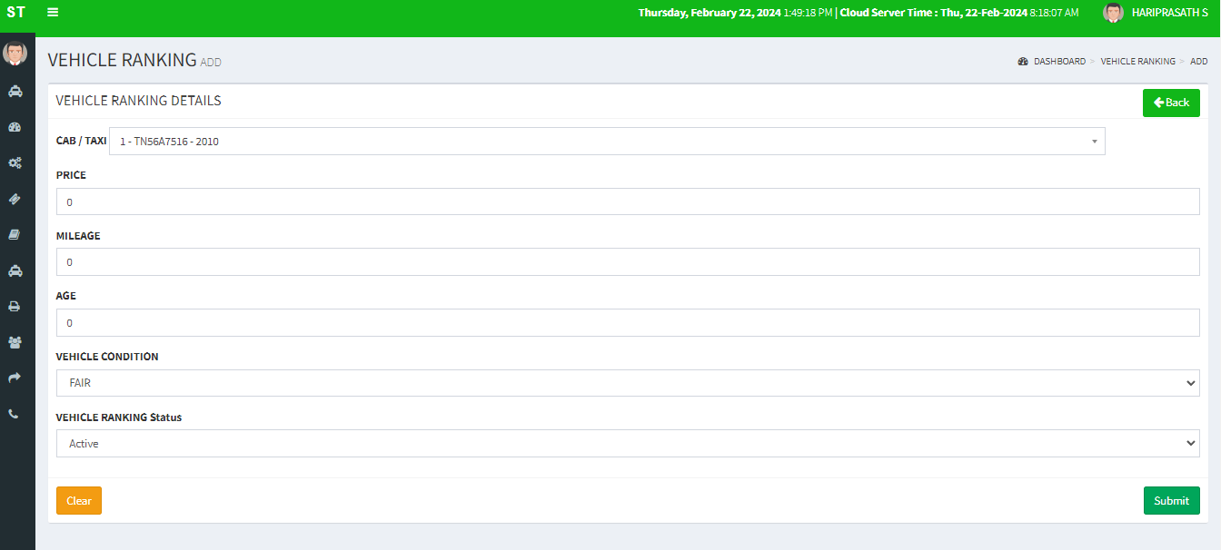

**A6. VEHICLE EDIT FORM**

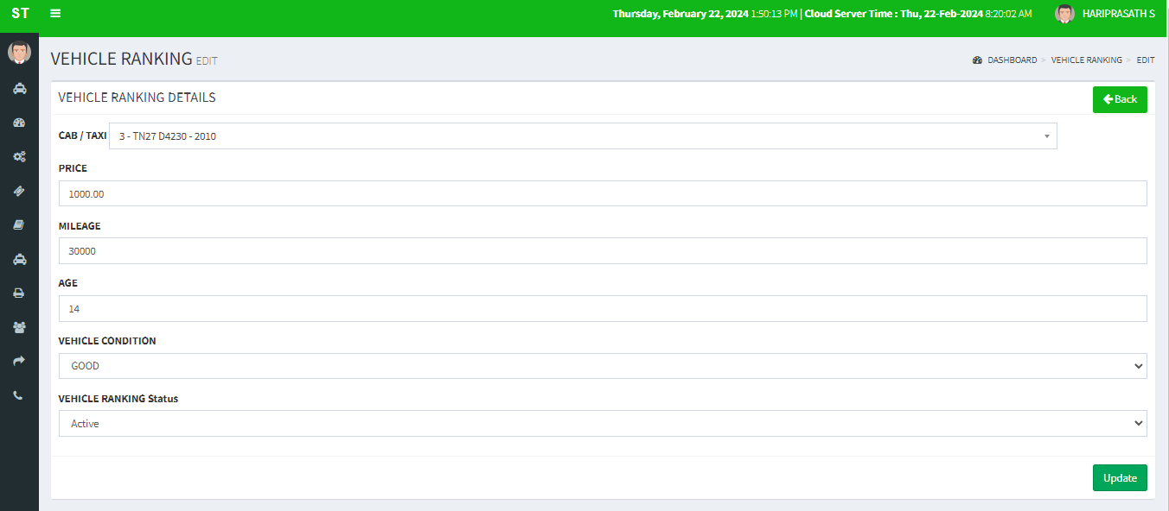

**APPENDIX – B (REPORTS)**

**B1. CAB VIEW REPORT**

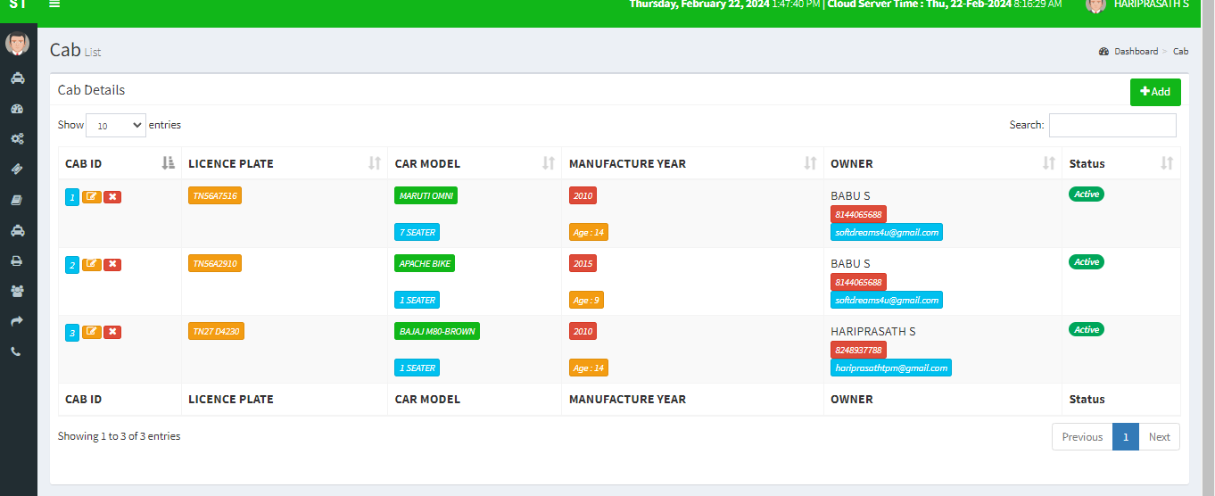

**B2. CAB MODEL VIEW REPORT**

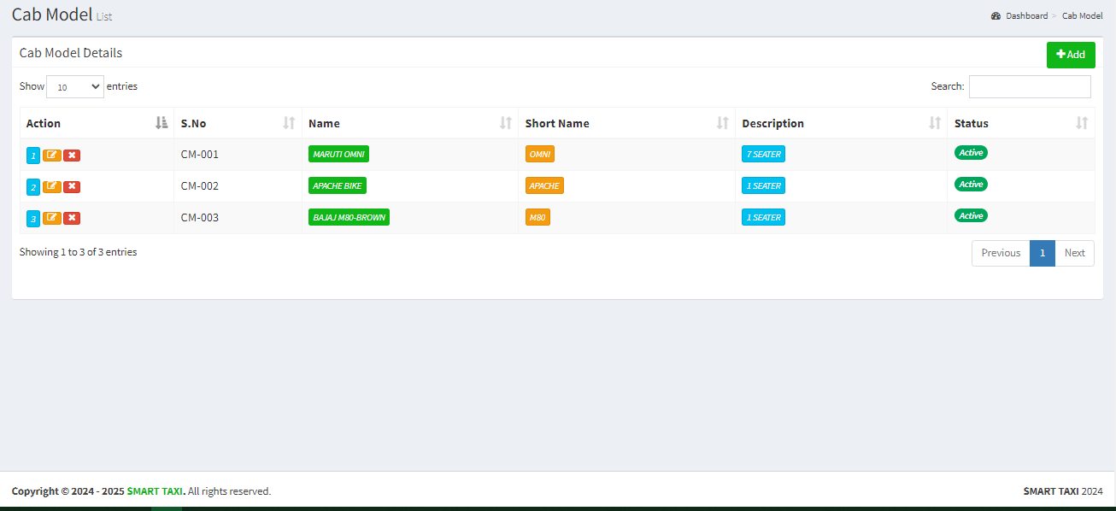

**B3. VEHICLE VIEW REPORT**

